Baseball description

Each team has 9 hitters who hit in order (after the ninth hitter, the first hitter goes again). Each hitter has a certain chance to get a hit (which I provided in the homework description). There are four bases in a diamond shape that the hitter tries to run around after hitting the ball. The hitter hits from the bottom base and runs counter-clockwise around. The field looks like this:

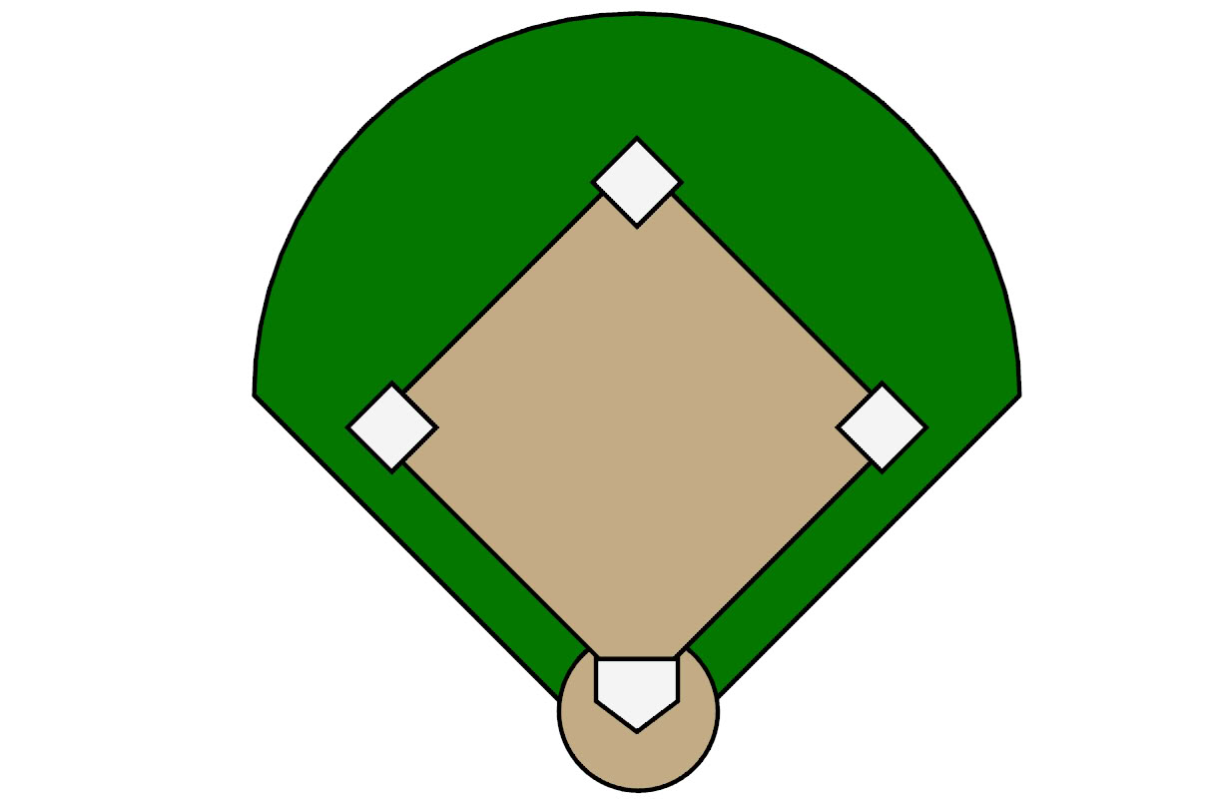

He has a 50% chance of making it around one base (called a single), a 20% chance of making it two bases (a double), a 10% chance of making it three bases (a triple) and a 20% chance of making it all the way around (home run). Once a player is on base, they become a “runner”. A player on base can make it further around the diamond when the hitters after them get a hit. If a runner makes it all the way around and back to the bottom (home) base, they score a “run” for their team. If a player does not get a hit in his turn, he records an “out” for his team. Once the team as a whole gets 3 outs, the inning is over. A player who is on base will move according to the following table. The top row is what type of hit the current hitter gets. The left column is where the runner is. The entries in the table are where the runner ends up after the current hitter finishes his turn.

|  |  |  |  |  |  |  |
| --- | --- | --- | --- | --- | --- | --- |
|  | What the Hitter does | Out | Single | Double | Triple | Home run |
| Where the runner is |  |  |  |  |  |  |
| 1st Base |  | 1st Base | 3rd base | Run | Run | Run |
| 2nd base |  | 2nd base | Run | Run | Run | Run |
| 3rd base |  | 3rd base | Run | Run | Run | run |